# Mask_RCNN

First, I need to configure the environment by using the command

pip install -r requirements.txt

And then I download the whole project from git hub

git clone https://github.com/matterport/Mask_RCNN.git

Then I need to do the set up by using the commend, and run the mask_cnn on the dog image test dataset

python setup.py install

python mask_cnn.py splash --weight=/mask_rcnn_balloon.h5 --image=/dog.jpg

The first time I got an error message that the weight file (mask_rcnn_balloon.h5) permission was denied. So, I need to authorise the weight first by using

sudo chmod 755 'mask_rcnn_coco.h5'

Then run the program again

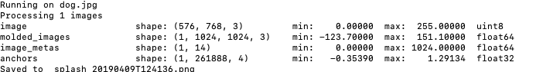

There is an output image in the current working folder

And we check the output image



Seems like the model doesn’t recognize the dog.

If we try the original dataset that provide by the model



python mask_cnn.py splash --weight=mask_rcnn_balloon.h5 --image=test.jpg

The result is



In this picture, the model recognize the balloon as the colour part.

And I try another picture with a batch of balloons in the picture



And the result is nice as the application recognize most of balloons



Conclusion:

In this experiment we can see that different model runs differently. And each model or network has its own area.

Such as yolov3 may good at animal, such as dog, racoon… And Mask_RCNN can recognize the balloon perfectly. But it cannot recognize dog as we use the test picture.

# Yolo

As there are some pretrained model that has image recognition function, I would like to use some of them to recognize my own photos which were taken by myself.

Those photos include all perspective: building, birds, animals, hand, home decoration, plants.

I will first try the application named YOLOv2 in Keras and Applications

From the introduction it can recognize a variety of stuffs, including animals, buildings, humans, street view ( which can be utilized in self driving ), even some blood cell( which can be used in health information)

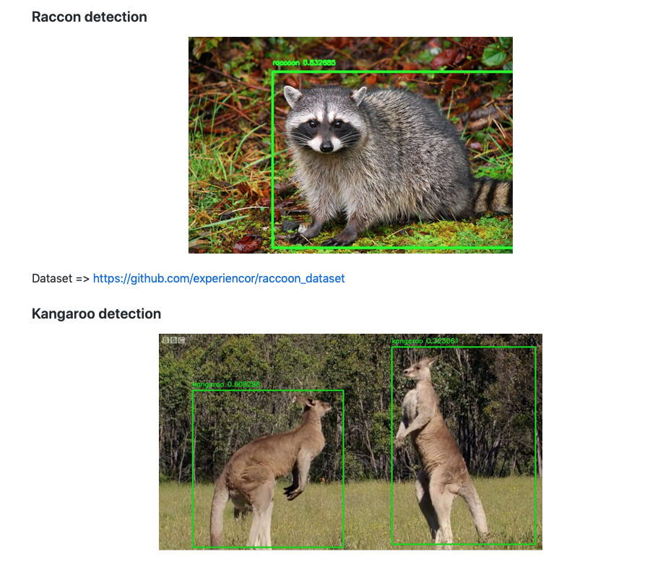

And first I take my own photos, it includes animals, home outside view, home stuff, and to see weather they can be recognized.

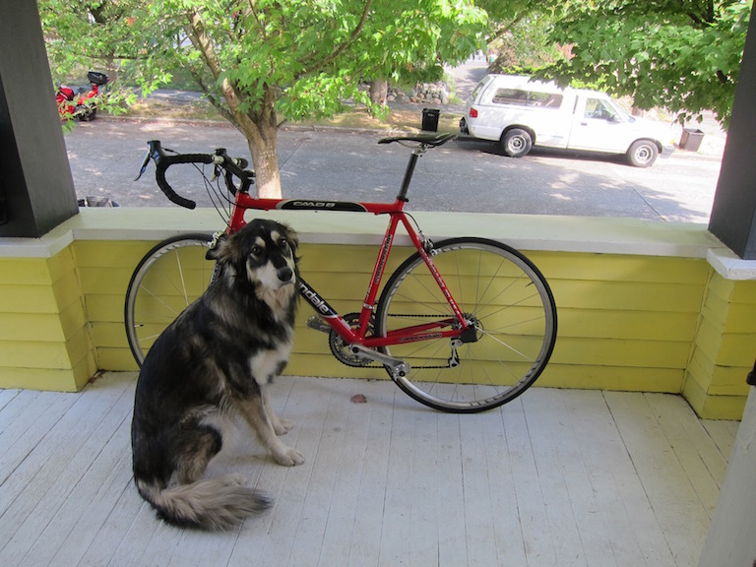

Here is another thing we need to be recognized as the pixel of the picture cannot be too large. If it is larger than the request, we need to convert it to the model request.

Here is the python programming we use from yolo

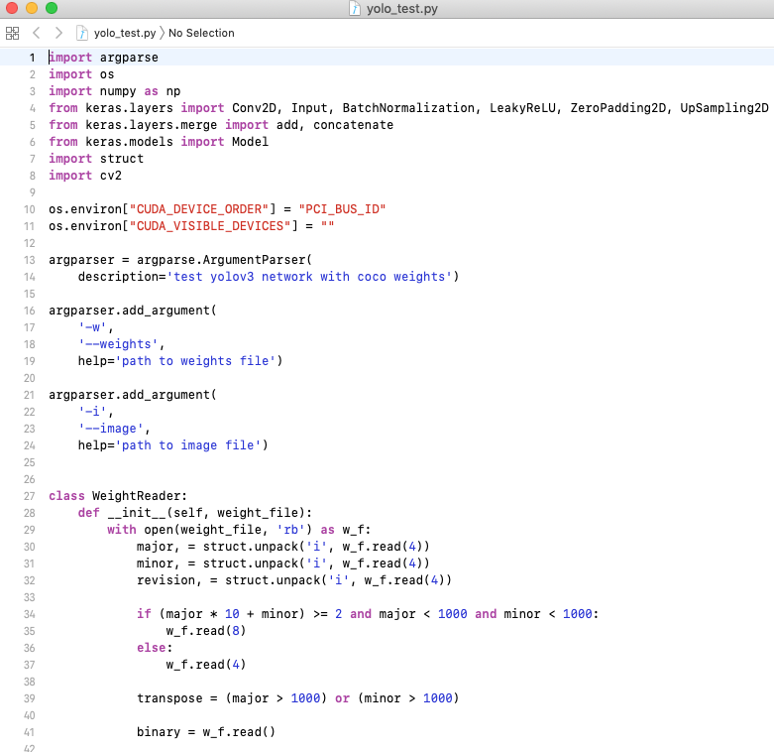

And we use the weight that provide by the test

python yolo_test.py -w yolov3.weights -i dog.jpg

Here is the running process

